**Repetition Practice Problems with while loop**

1. Write a program that takes a command-line argument n and prints a table of the powers of 2 that are less than or equal to 2^n till 256 is reached.

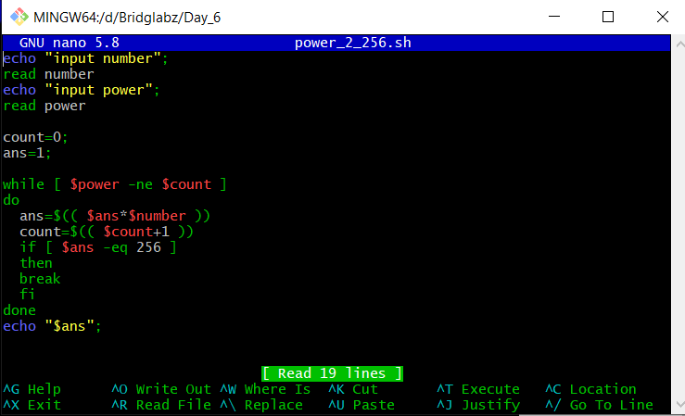

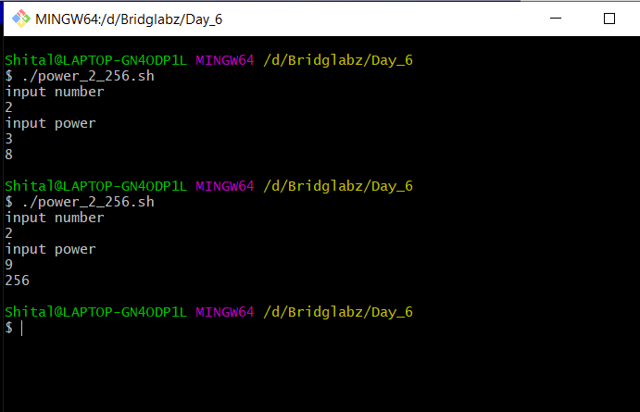

2. Find the Magic Number

a. Ask the user to think of a number n between 1 to 100

b. Then check with the user if the number is less then n/2 or greater

c. Repeat till the Magic Number is reached.

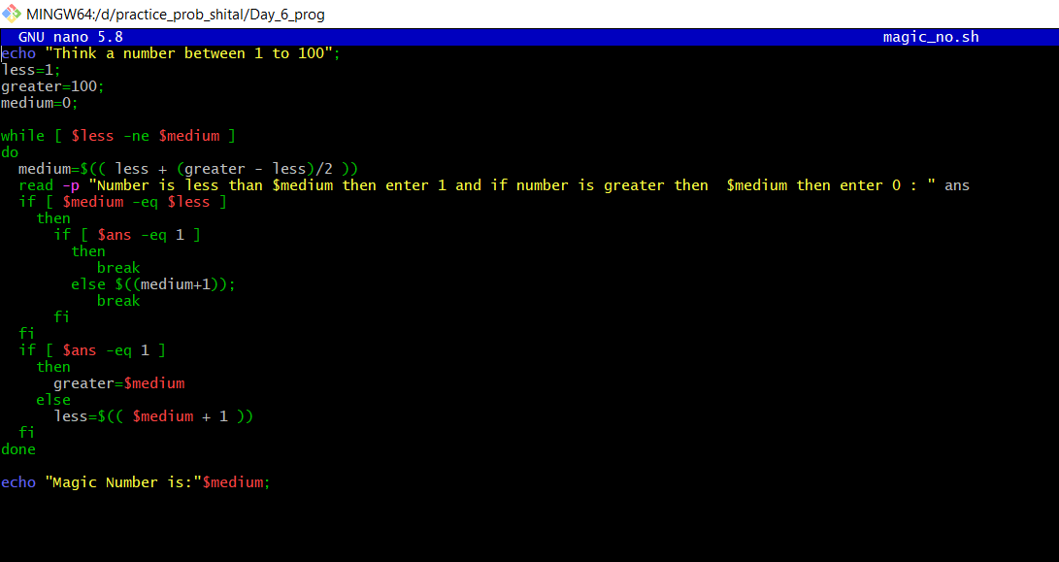

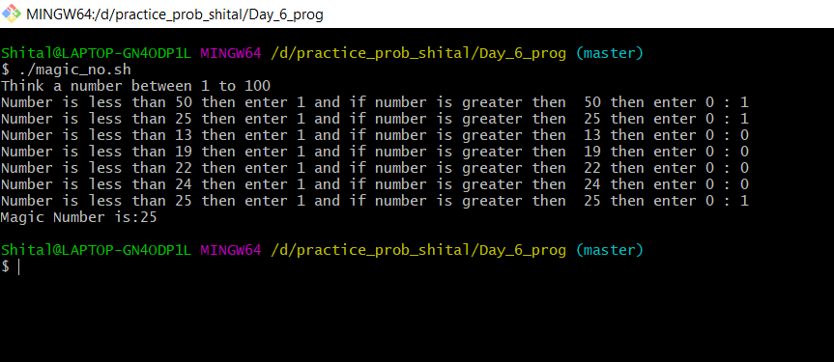

1. Extend the Flip Coin problem till either Heads or Tails wins 11 times.

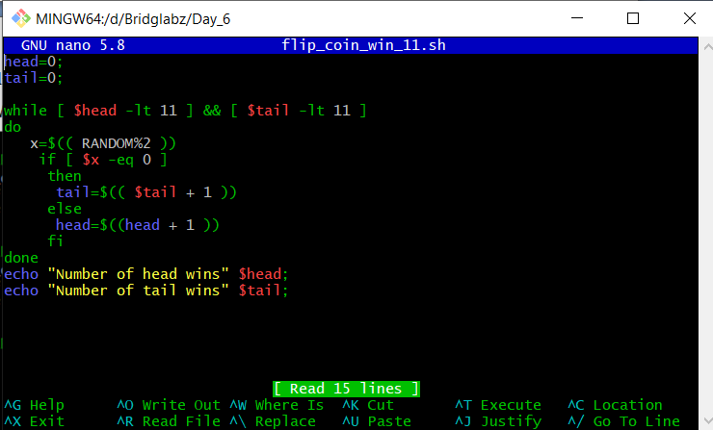

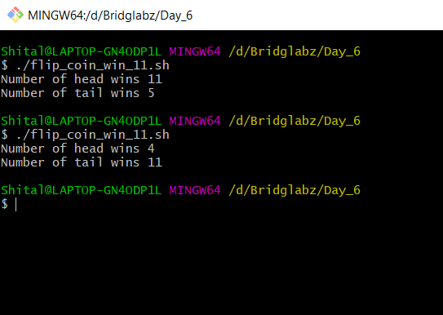

1. Write a Program where a gambler starts with Rs 100 and places Re 1 bet until he/she goes broke i.e. no more money to gamble or reaches the goal of Rs 200. Keeps track of number of times won and number of bets made.

